Want to buy fairly traded or ecofriendly goods, but don’t know where to start?
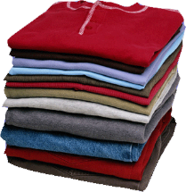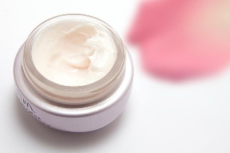
Whether it’s, clothes, beauty and wellness, flowers, wine, or even gold, have a look at The Fairtrade Foundation web site
https://www.fairtrade.org.uk/buying-fairtrade
Also on line

https://www.neast.org.uk/fairtrade/wiki/doku.php?id=start

https://www.ebay.co.uk/str/oxfamshopuk

https://www.ethicalsuperstore.com/

https://onlineshop.oxfam.org.uk/category/sourced-by-oxfam

https://benandanna.uk/
Local Refill shops
Planet Organic 17 - 21 High Street, Ealing W5 5DB
Earthical, 194 Northfields Ave, W13 9SJ
The Source: Bulk foods 24 Turnham Green Terrace, Chiswick, W4 1QP

Look out in local shops for

Lidl’s Way to Go Fairtrade Chocolate Bar
Aldi’s Moser Roth Fairtrade Blonde Chocolate
Asda’s Extra Special Ethiopian Fairtrade Ground Coffee
Tesco's Vergelegen Fairtrade Sauvignon Blanc
Clipper's Everyday Fairtrade Tea Bags
Cafédirect's Fairtrade Empower Smooth Roast Ground Coffee
Tony Chocolonley’s Fairtrade Little Bits bags
Many products in the Co-op

